Server Side Code

# Assingment-5

1. **Php code**

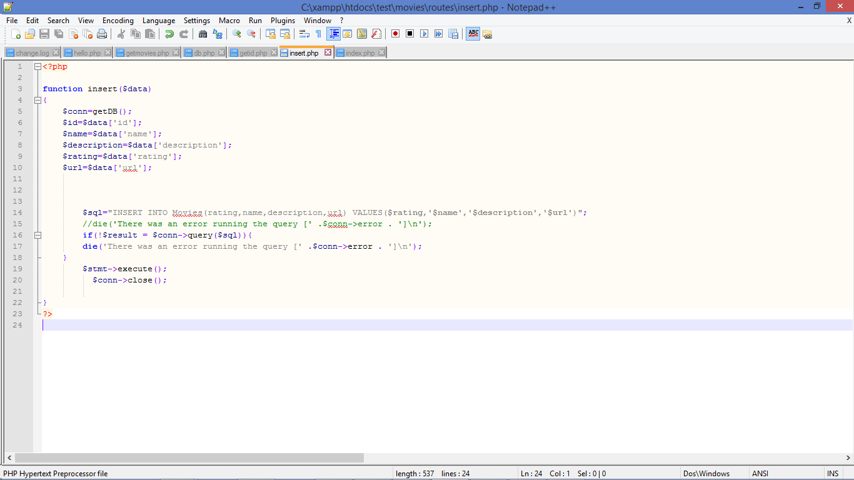

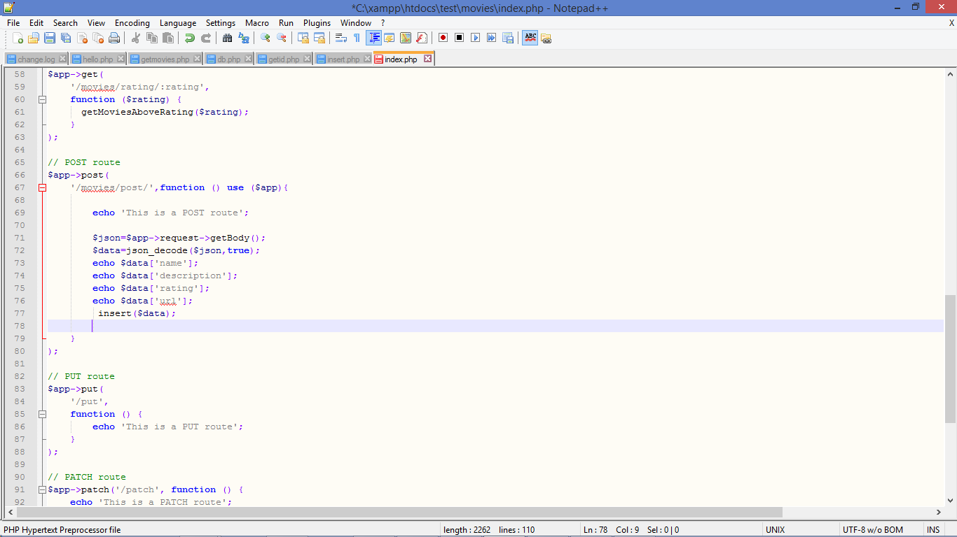

**The UI for Entering the Movie Details:**

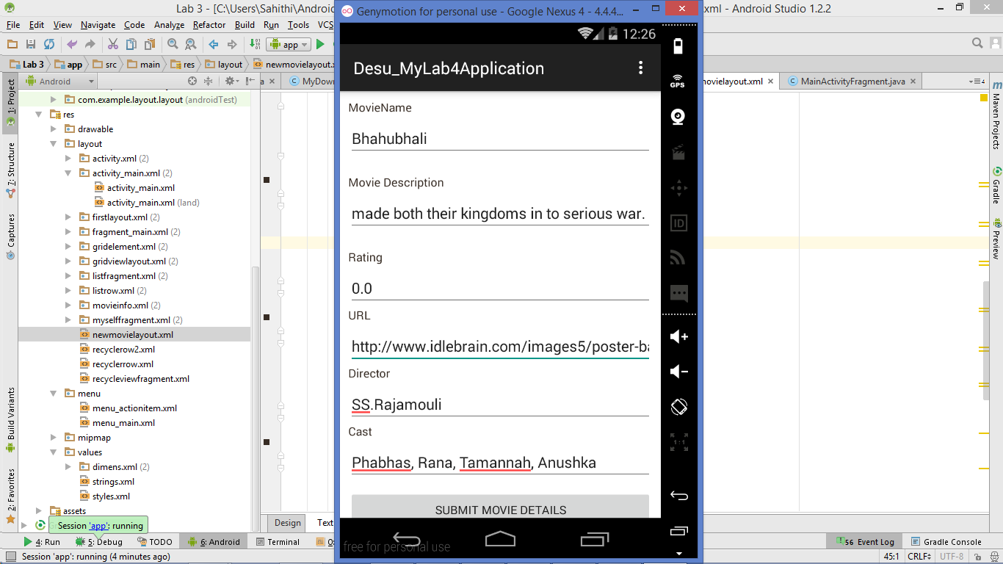

**Once the Details are loaded, it gives a message that the details are uploaded**

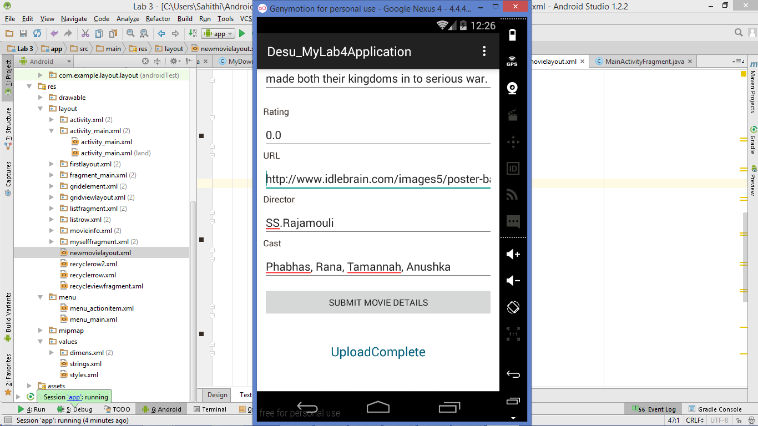

**Reflecting the new movie added in the Recycler View:**

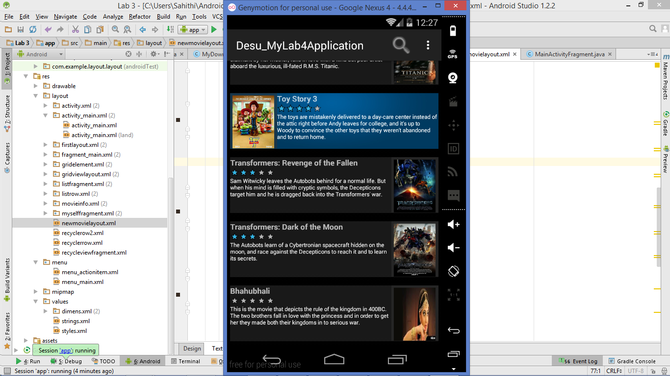

The new movie “Bhahubhali” which is not in the given list is added using POST request from the Anroid UI( which displays Image, Moviename and Description)

**The App Side Code**

**Xml code:**

*<?***xml version="1.0" encoding="utf-8"***?>*<**ScrollView xmlns:android="http://schemas.android.com/apk/res/android"  
 android:layout_width="fill_parent"  
 android:layout_height="fill_parent"  
 android:fillViewport="true"**>  
 <**RelativeLayout  
 android:layout_width="fill_parent"  
 android:layout_height="wrap_content" android:background="#fff"**>  
  
  
 *<!-- Registration Form -->* <**LinearLayout  
 xmlns:android="http://schemas.android.com/apk/res/android"  
 android:orientation="vertical"  
 android:layout_width="match_parent"  
 android:layout_height="wrap_content"  
 android:padding="10dip"** >  
 *<!-- Full Name Label -->* <**TextView android:layout_width="fill_parent"  
 android:layout_height="wrap_content"  
 android:textColor="#372c24"  
 android:text="MovieName"**/>  
 <**EditText android:id="@+id/MovieName"  
 android:layout_width="fill_parent"  
 android:layout_height="wrap_content"  
 android:layout_marginTop="5dip"  
 android:singleLine="true"  
 android:layout_marginBottom="20dip"**/>  
 *<!-- Email Label -->* <**TextView android:layout_width="fill_parent"  
 android:layout_height="wrap_content"  
 android:textColor="#372c24"  
 android:text="Movie Description"**/>  
 <**EditText android:id="@+id/description"  
 android:layout_width="fill_parent"  
 android:layout_height="wrap_content"  
 android:layout_marginTop="5dip"  
 android:singleLine="true"  
 android:layout_marginBottom="20dip"**/>  
 *<!-- Password Label -->* <**TextView android:layout_width="fill_parent"  
 android:layout_height="wrap_content"  
 android:textColor="#372c24"  
 android:text="Rating"**/>  
 <**EditText android:id="@+id/rating"  
 android:layout_width="fill_parent"  
 android:layout_height="wrap_content"  
  
 android:singleLine="true"  
 android:layout_marginTop="5dip"**/>  
  
  
  
 <**TextView android:layout_width="fill_parent"  
 android:layout_height="wrap_content"  
 android:textColor="#372c24"  
 android:text="URL"**/>  
 <**EditText android:id="@+id/url"  
 android:layout_width="fill_parent"  
 android:layout_height="wrap_content"  
  
  
 android:singleLine="true"  
 android:layout_marginTop="5dip"**/>  
 <**TextView android:layout_width="fill_parent"  
 android:layout_height="wrap_content"  
 android:textColor="#372c24"  
 android:text="Director"**/>  
 <**EditText android:id="@+id/director"  
 android:layout_width="fill_parent"  
 android:layout_height="wrap_content"  
  
 android:singleLine="true"  
 android:layout_marginTop="5dip"**/>  
 <**TextView android:layout_width="fill_parent"  
 android:layout_height="wrap_content"  
 android:textColor="#372c24"  
 android:text="Cast"**/>  
 <**EditText android:id="@+id/cast"  
 android:layout_width="fill_parent"  
 android:layout_height="wrap_content"  
  
 android:singleLine="true"  
 android:layout_marginTop="5dip"**/>  
  
  
 *<!-- Register Button -->* <**Button android:id="@+id/Submit"  
 android:layout_width="fill_parent"  
 android:layout_height="wrap_content"  
 android:layout_marginTop="10dip"  
 android:text="Submit Movie Details"**/>  
  
 *<!-- Link to Login Screen -->* <**TextView android:id="@+id/Upload"  
 android:layout_width="fill_parent"  
 android:layout_height="wrap_content"  
 android:layout_marginTop="40dip"  
 android:layout_marginBottom="40dip"  
  
 android:gravity="center"  
 android:textSize="20dip"  
 android:textColor="#025f7c"**/>  
  
 </**LinearLayout**>  
 *<!-- Registration Form Ends -->* </**RelativeLayout**>  
</**ScrollView**>

**Code in the Fragment:**

**package** com.example.layout.layout;  
  
**import** android.os.Bundle;  
**import** android.support.v4.app.Fragment;  
**import** android.view.LayoutInflater;  
**import** android.view.View;  
**import** android.view.ViewGroup;  
**import** android.widget.EditText;  
**import** android.widget.TextView;  
**import** android.widget.Button;  
  
**import** java.util.HashMap;  
  
**import** javax.security.auth.Subject;  
  
  
*/**  
 * A placeholder fragment containing a simple view.  
 */***public class** EnterNewMovie **extends** Fragment {  
 **public static final** String ***ARG_OPTION***=**"argument_option"**;  
 **public** String **MovieName**;  
 **public** String **Description**;  
 **public** Double **Rating**;  
 **public** String **Url**;  
 **public** String **Director**;  
 **public** String **Cast**;  
 TextView **Upload**;  
 **public** HashMap **Movie**;  
 EditText **moviename**,**description**,**url**,**rating**,**director**,**cast**;  
  
  
 **public static** EnterNewMovie newInstance(**int** option)  
 {  
 EnterNewMovie fragment=**new** EnterNewMovie();  
 Bundle args=**new** Bundle();  
 args.putInt(***ARG_OPTION***,option);  
 fragment.setArguments(args);  
 **return** fragment;  
  
 }  
 **private** HashMap createMovie(String name, String description,  
 **double** rating, String director, String stars, String url) {  
 HashMap movie = **new** HashMap();  
  
 movie.put(**"name"**, name);  
 movie.put(**"description"**, description);  
 movie.put(**"rating"**,rating);  
 movie.put(**"director"**,director);  
 movie.put(**"stars"**,stars);  
 movie.put(**"url"**, url);  
  
 **return** movie;  
 }  
  
 **public** EnterNewMovie() {  
 }  
  
 @Override  
 **public** View onCreateView(LayoutInflater inflater, ViewGroup container,  
 Bundle savedInstanceState) {  
 View view=inflater.inflate(R.layout.***newmovielayout***, container, **false**);  
 **moviename**=(EditText)view.findViewById(R.id.***MovieName***);  
 **description**=(EditText)view.findViewById(R.id.***description***);  
 **url**=(EditText)view.findViewById(R.id.***url***);  
 **rating**=(EditText)view.findViewById(R.id.***rating***);  
 String rating_=**rating**.getText().toString();  
 *// Rating=Double.parseDouble(rating_);* **director**=(EditText)view.findViewById(R.id.***director***);  
  
 **cast**=(EditText)view.findViewById(R.id.***cast***);  
  
 **Upload**=(TextView) view.findViewById(R.id.***Upload***);  
 Button Sumbit=(Button)view.findViewById(R.id.***Submit***);  
 Sumbit.setOnClickListener(**new** View.OnClickListener() {  
 @Override  
 **public void** onClick(View v) {  
  
 **MovieName**=**moviename**.getText().toString();  
 **Description**=**description**.getText().toString();  
 **Url**=**url**.getText().toString();  
 **Director**=**director**.getText().toString();  
 **Cast**=**cast**.getText().toString();  
 **Movie**=**new** HashMap();  
 **Movie**=createMovie(**MovieName**, **Description**, 0.0, **Director**, **Cast**,**Url**);  
 String url_ = MovieDataJson.*PHP_SERVER* + **"post/"**;  
 UploadMovieAsyncTask uploadMovieAsyncTask = **new** UploadMovieAsyncTask(**Movie**, **Upload**);  
 uploadMovieAsyncTask.execute(**new** String[]{url_});  
  
 }  
 });  
 **return** view;  
  
 }  
}

**Code in Async Task:**

**package** com.example.layout.layout;  
**import** android.os.AsyncTask;  
**import** android.widget.TextView;  
**import** java.lang.ref.WeakReference;  
**import** java.util.HashMap;  
  
*/**  
 * Created by Sahithi on 6/24/2015.  
 */***public class** UploadMovieAsyncTask **extends** AsyncTask<String,Void,String> {  
  
**private** HashMap **Movie**=**new** HashMap();  
 **private final** WeakReference<TextView> **TextViewWeakReference**;  
 **public** UploadMovieAsyncTask(HashMap Movie,TextView Upload)  
 {  
 **this**.**Movie**=Movie;  
 **TextViewWeakReference**=**new** WeakReference<TextView>(Upload);  
 }  
 **protected** String doInBackground(String...urls)  
 {  
 MyUtility.*uploadJSON*(urls[0],**Movie**);  
 String uploadstatus=**"UploadComplete"**;  
  
 **return** uploadstatus;  
 }  
  
 **protected void** onPostExecute(String UploadStatus)  
 {  
  
 TextView UploadText=**TextViewWeakReference**.get();  
 UploadText.setText(UploadStatus);  
 }  
  
  
  
}

**Code for JSON upload**

*// Upload Json data to server***public static void** uploadJSON(String url,HashMap Movie) {  
 String line;  
 **try** {  
 URL urlObj = **new** URL(url);  
 HttpURLConnection httpConnection = (HttpURLConnection) urlObj.openConnection();  
 httpConnection.setDoOutput(**true**);  
 httpConnection.setRequestMethod(**"POST"**);  
 httpConnection.setRequestProperty(**"Content-Type"**, **"application/json"**);  
 httpConnection.connect();  
 *// Send the JSON data* JSONObject jsonParam = **new** JSONObject();  
 jsonParam.put(**"id"**,Movie.get(**"name"**));  
 jsonParam.put(**"name"**, Movie.get(**"name"**));  
 jsonParam.put(**"description"**,Movie.get(**"description"**));  
 jsonParam.put(**"stars"**,Movie.get(**"stars"**));  
 jsonParam.put(**"length"**,**null**);  
 jsonParam.put(**"image"**,**null**);  
 jsonParam.put(**"year"**,**null**);  
 jsonParam.put(**"rating"**,Movie.get(**"rating"**));  
 jsonParam.put(**"director"**,Movie.get(**"director"**));  
 jsonParam.put(**"url"**,Movie.get(**"url"**));  
  
 OutputStreamWriter out = **new** OutputStreamWriter(httpConnection.getOutputStream());  
 out.write(jsonParam.toString());  
 out.close();  
 *// Read the response, if needed* **int** number=httpConnection.getResponseCode();  
 **if** (httpConnection.getResponseCode() == HttpURLConnection.***HTTP_OK***) {  
 InputStream stream = httpConnection.getInputStream();  
 BufferedReader reader = **new** BufferedReader(**new** InputStreamReader(stream));  
 **while** ((line = reader.readLine()) != **null**) {  
 Log.*d*(**"Uploading Finished"**, line); *// for debugging purpose* }  
 reader.close();  
 }  
 } **catch** (UnknownHostException e1) {  
 Log.*d*(**"MyDebugMsg"**, **"Unknown Host exception in uploadJSON()"**);  
 e1.printStackTrace();  
 } **catch** (Exception ex) {  
 Log.*d*(**"MyDebugMsg"**, **"Exception in uploadJSON()"**);  
 ex.printStackTrace();  
 }  
}

Reflecting the new record added in the [www.example.com/movies/](http://www.example.com/movies/)

